**Name:** Atharva Salitri

**Year & Branch:** TY-CSAI-B

**Batch:** 2

**Roll no:** 29

**PRN:** 12310120

**Subject:** Cloud Computing

**Cloud Computing Assignment 5**

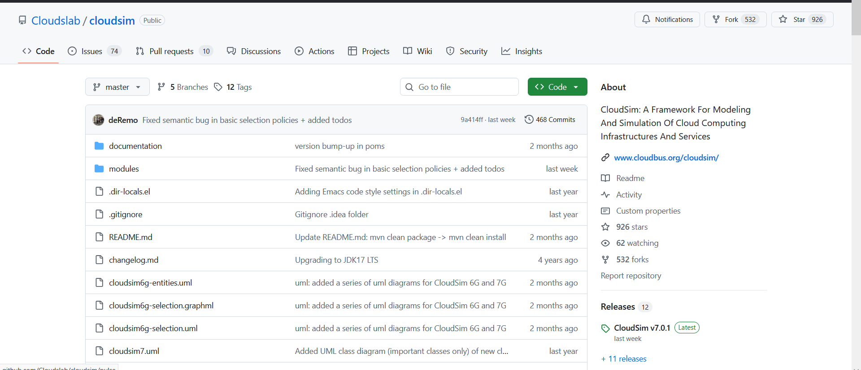

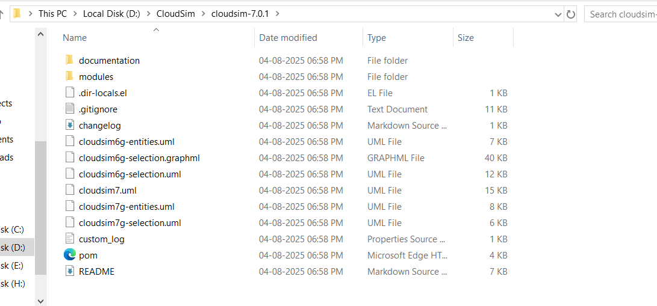

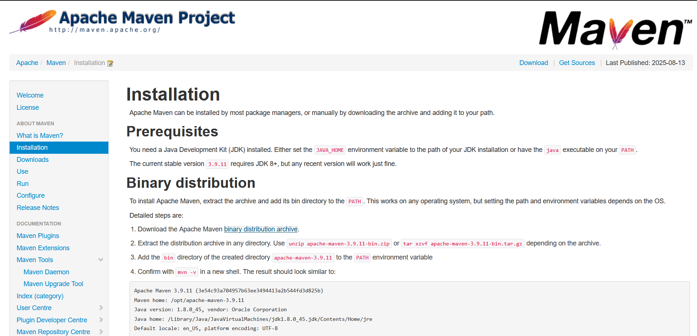

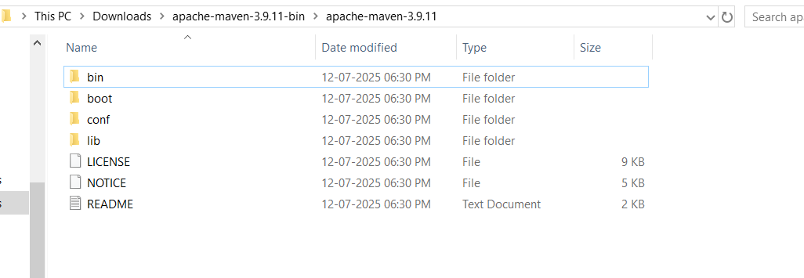

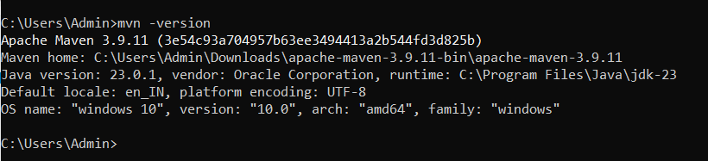

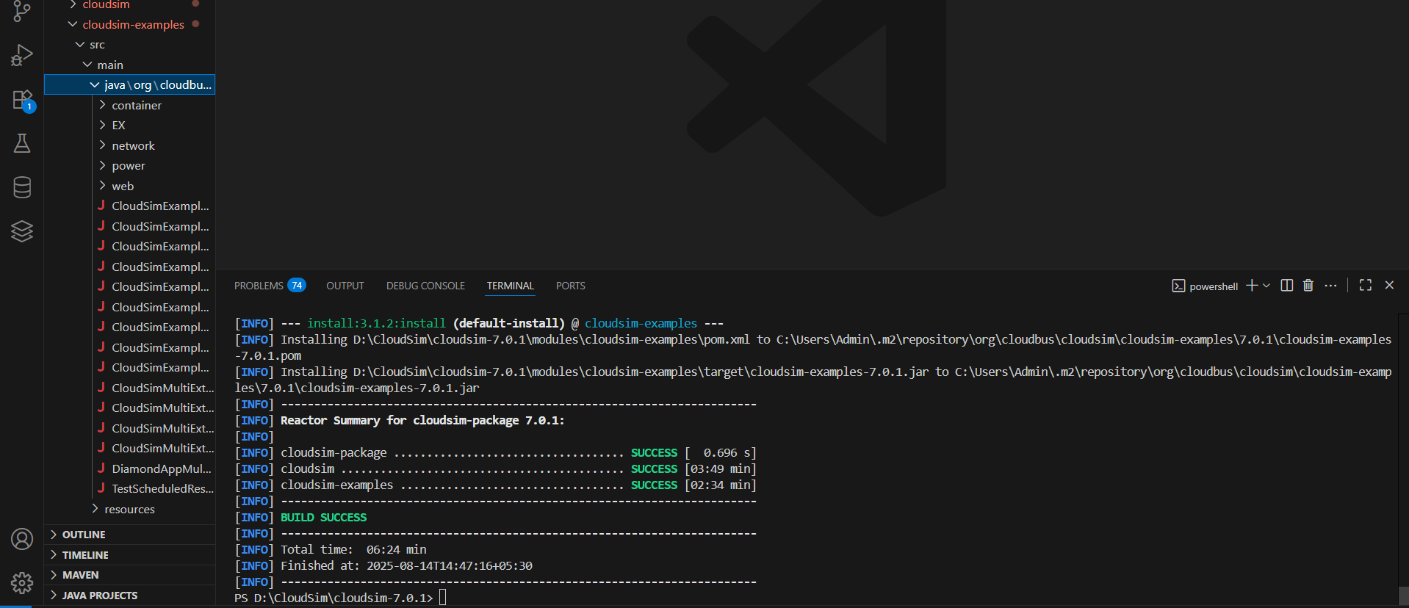

After running example 9 and updating the example

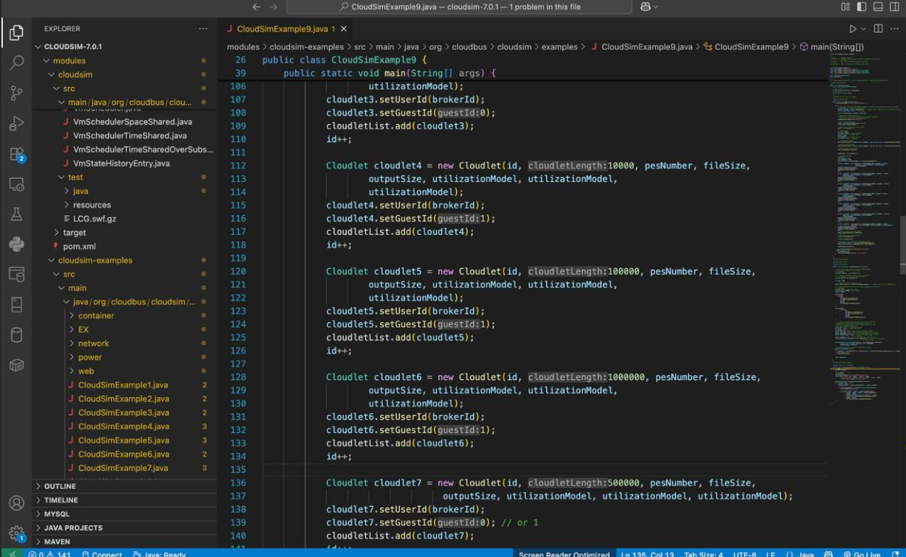

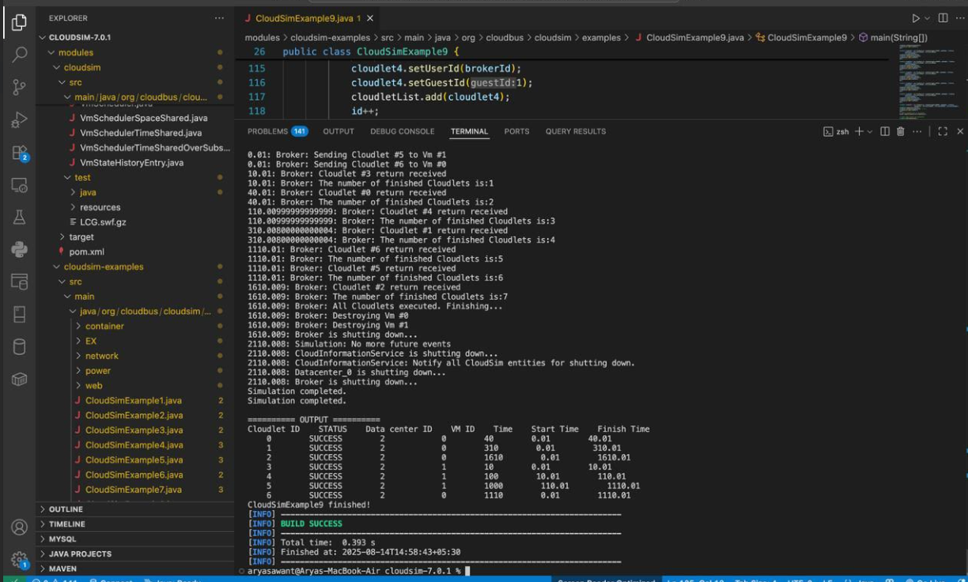

Changes:

// Create a time-sharing VM with decreased resources

vmlist.add(new Vm(0, brokerId, 500, 1, 256, 500, 5000, "Xen", new CloudletSchedulerTimeShared()));

// Create a space-sharing VM with decreased resources

vmlist.add(new Vm(1, brokerId, 500, 1, 256, 500, 5000, "Xen", new CloudletSchedulerSpaceShared()));

Cloudlet cloudlet1 = new Cloudlet(id, 5000, pesNumber, fileSize, outputSize, utilizationModel, utilizationModel, utilizationModel);

cloudlet1.setUserId(brokerId);

cloudlet1.setGuestId(0);

cloudletList.add(cloudlet1);

id++;

Cloudlet cloudlet2 = new Cloudlet(id, 50000, pesNumber, fileSize, outputSize, utilizationModel, utilizationModel, utilizationModel);

cloudlet2.setUserId(brokerId);

cloudlet2.setGuestId(0);

cloudletList.add(cloudlet2);

id++;

Cloudlet cloudlet3 = new Cloudlet(id, 500000, pesNumber, fileSize, outputSize, utilizationModel, utilizationModel, utilizationModel);

cloudlet3.setUserId(brokerId);

cloudlet3.setGuestId(0);

cloudletList.add(cloudlet3);

id++;

Cloudlet cloudlet4 = new Cloudlet(id, 5000, pesNumber, fileSize, outputSize, utilizationModel, utilizationModel, utilizationModel);

cloudlet4.setUserId(brokerId);

cloudlet4.setGuestId(1);

cloudletList.add(cloudlet4);

id++;

Cloudlet cloudlet5 = new Cloudlet(id, 50000, pesNumber, fileSize, outputSize, utilizationModel, utilizationModel, utilizationModel);

cloudlet5.setUserId(brokerId);

cloudlet5.setGuestId(1);

cloudletList.add(cloudlet5);

id++;

Cloudlet cloudlet6 = new Cloudlet(id, 500000, pesNumber, fileSize, outputSize, utilizationModel, utilizationModel, utilizationModel);

cloudlet6.setUserId(brokerId);

cloudlet6.setGuestId(1);

cloudletList.add(cloudlet6);

